# CRM GUIDE

Contents

1. Creating a New Contact 2

2. Linking a contact 4

3. High Needs and Suicidal Ideation 5

# Creating a New Contact

* 1. Under ‘Contacts’ click ‘New’

* 1. Enter client’s details.
     1. **Contact Information**
        1. First Name
        2. Last Name
        3. Email
        4. Gender
        5. Date of Birth
        6. Mobile Phone
        7. Aboriginal/Torres Strait Islander
        8. Address (using the middle column of CRM)
     2. **Contact Type**
     3. **Service** 
        1. Status
        2. Service
        3. Enlistment
        4. Discharge Date
        5. Discharge Reason
        6. Role
        7. Deployment Summary
        8. Discharge
     4. **Personal**
        1. Marital Status
        2. Spouse/Partner Name
        3. Children or dependent
        4. Are children living with you
        5. Culturally and Linguistically Diverse
     5. PMKeys Number
     6. Service Card and Pension
     7. DVA Number

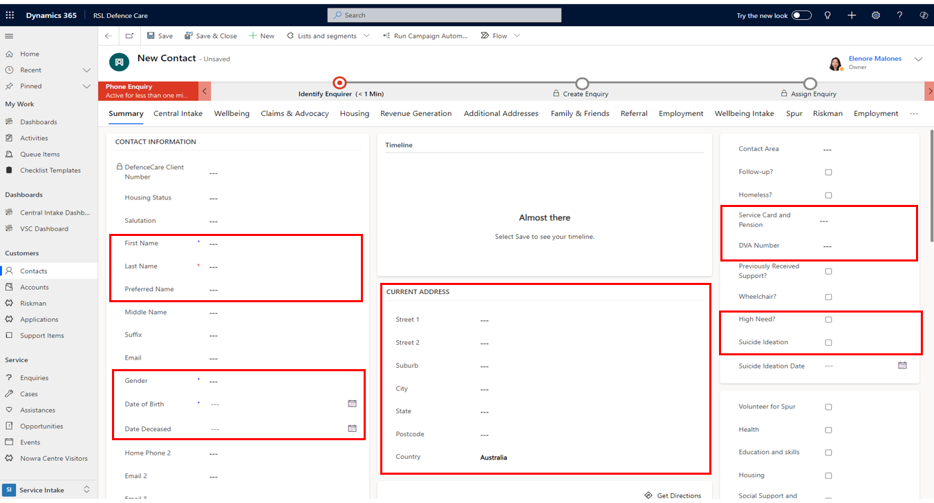

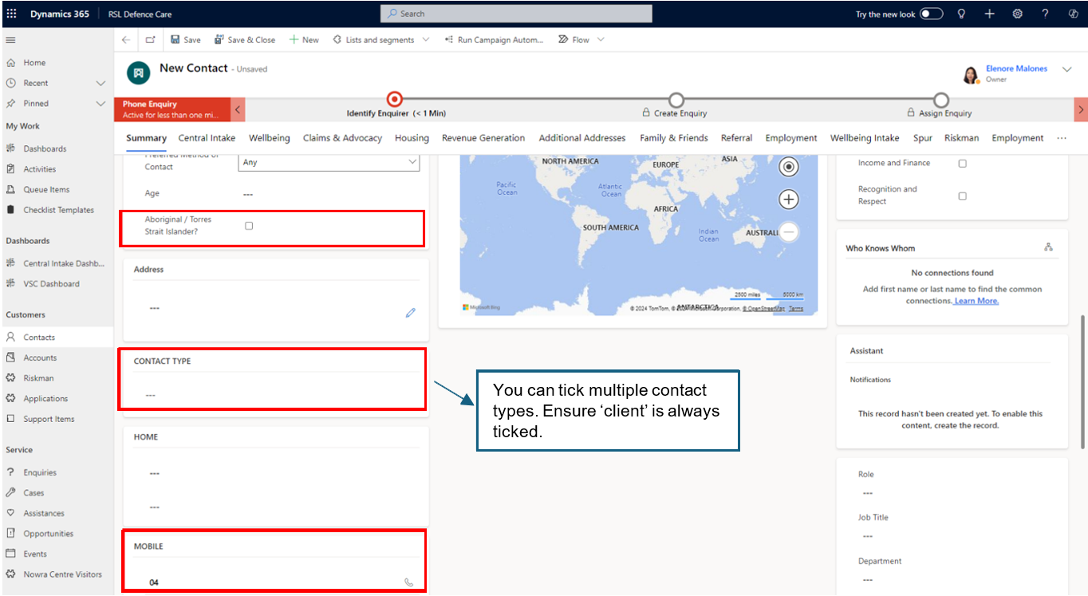

* 1. You may add any useful and relevant information under phone notes such preferred time to

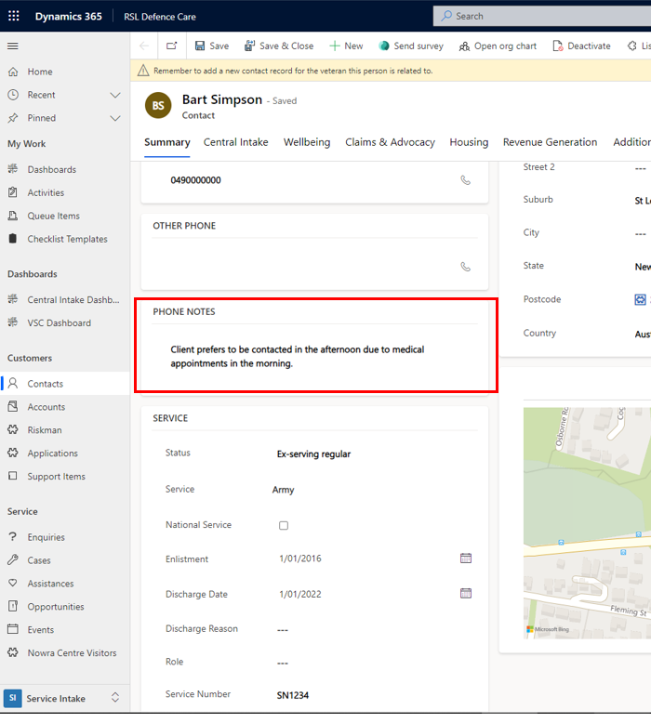

# Linking a contact

*Please note that to be able to link contacts, the veteran’s details will need to be entered and saved as a contact first before creating a contact for family members.*

* 1. Click contact type
  2. Tick ‘client’ and ‘relative’
  3. Choose relationship type and enter veteran’s name in the box to start search
  4. Click save when done

# High Needs and Suicidal Ideation

* 1. If the client discloses previous suicidal ideation, tick the suicidal ideation box and add the date if possible.
  2. Tick the ‘High Needs’ box if:
     1. the client is experiencing multiple challenges that significantly affect their overall wellbeing and is receiving (or will require) additional support from other agencies.
     2. there is significant information that might be useful for another staff member to know to fulfill their duties or when engaging with the client especially regarding staff safety.
  3. In ‘Details’ box, you may add a brief note or description of the client’s complexity and/or useful information for other staff members.

When writing your notes:

* Always use respectful language
* Be objective and concise
* If unsure, consult with your manager and/or team

